Additional Health Precautions for CBC

Weekday Preschool

Fall 2020

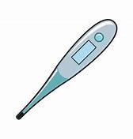

Daily temperature checks for Preschool Staff and Preschool children will be taken upon arrival.

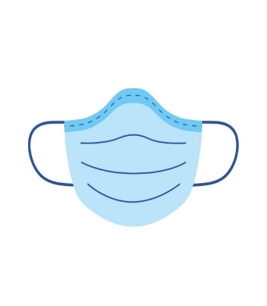

Face coverings are required for any adult entering the Preschool area. Teachers will wear a mask when working with children.

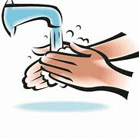

There will be even more thorough and frequent hand washing, as well as an intensified practice of disinfecting and sanitizing surfaces and items in classrooms.



The number of children per class will be smaller and individual classrooms will remain self-contained in order to fight the spread of germs.